7.25: a) Gravity does negative work, 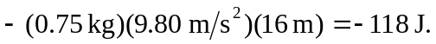 b) Gravity does 118 J of positive work. c) Zero d) Conservative; gravity does no net work on any complete round trip.

